9 SCIENCE 2016

CHEMISTRY TEST ONE

Name: ____________________ Mark: /48

Percentage: %

Multiple Choice Answer Sheet: circle or cross through your responses.

1. A B C D 14. A B C D
2. A B C D 15. A B C D
3. A B C D 16. A B C D
4. A B C D 17. A B C D
5. A B C D 18. A B C D
6. A B C D 19. A B C D
7. A B C D 20. A B C D
8. A B C D 21. A B C D
9. A B C D 22. A B C D
10. A B C D 23. A B C D
11. A B C D 24. A B C D
12. A B C D 25. A B C D
13. A B C D
SECTION A: MULTIPLE CHOICE (25 marks)

Select the most correct answer for each question below.

1. What changes between different isotopes of the same element?

(a) The neutrons.
(b) The protons.
(c) The electrons.
(d) The average atomic mass.

2. To work out the number of neutrons in an atom:

(a) Take the atomic number from the mass number.
(b) Take the mass number from the atomic number.
(c) Add the mass number to the atomic number.
(d) Add the number of electrons to the number of protons.

3. How many of the known elements are found naturally on Earth?

(a) 87
(b) 94
(c) 79
(d) 91

4. The definition that best describes the word ‘element’ is:

(a) The fundamental building block of all materials.
(b) A substance made up of only one type of atom.
(c) A substance made up of two or more types of atoms.
(d) A metal that has many atoms.

5. H₂O (water) is an example of a/an:

(a) Element.
(b) Crystal lattice.
(c) Compound.
(d) Mixture.

6. For a neutral (uncharged) atom, the number of electrons is equal to the:

(a) Number of protons.
(b) Number of neutrons.
(c) Isotopic number.
(d) Atomic mass.

7. The place of an element in the periodic table is determined by its:

(a) Atomic number.
(b) Mass number.
(c) Density.
(d) Chemical activity.

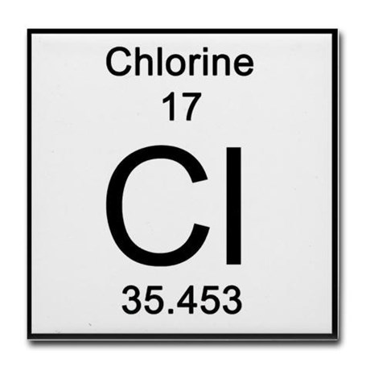
8. What is true about the following atom on the right?

(a) It has 17 protons and 35 neutrons.
(b) It has 17 protons and 18 electrons.
(c) It has 35 protons and 17 neutrons.
(d) It has 17 protons and 18 neutrons.

9. The centre of the atom is the:

(a) Nucleus.
(b) Proton.
(c) Neutron.
(d) Electron.

10. The atomic number of an atom is:

(a) The number of electrons plus the number of neutrons.
(b) The number of neutrons.
(c) The number of protons.
(d) The number of protons plus the number of neutrons.

11. The nucleus of an atom consists of:

(a) Electrons.
(b) Neutrons.
(c) Protons and neutrons.
(d) Protons, neutrons and electrons.

12. A single proton has what electrical charge?

(a) No charge.
(b) Positive charge.
(c) Negative charge.
(d) Either a positive or negative charge.

13. Which particles have approximately the same size and mass as each other?

(a) Neutrons and electrons.
(b) Electrons and protons.
(c) Protons and neutrons.
(d) None – they are all very different in size and mass.
14. The law of conservation of mass means that:

(a) Atoms are not lost or destroyed in a chemical reaction.
(b) The mass of a newly formed compound cannot be changed.
(c) In burning, part of the mass must be converted into fire in order for mass to be conserved.
(d) Molecules cannot be broken apart because this would result in less mass.

15. Plants undergo the process of photosynthesis within:

(a) Chloroplasts.
(b) Mitochondria.
(c) Stomata.
(d) The nucleus.

16. Where do plants get the carbon dioxide needed for photosynthesis?

(a) Water.
(b) The sun.
(c) The air.
(d) Glucose.

17. Cellular respiration occurs in:

(a) Animals only.
(b) Plants only.
(c) Animals and plants.
(d) Bacteria only.

18. Plants produce what two products in photosynthesis?

(a) Carbon dioxide and oxygen.
(b) Oxygen and glucose.
(c) Glucose and carbon dioxide.
(d) Hydrogen and glucose.

19. Plant cells have:

(a) Mitochondria only.
(b) Chloroplasts only.
(c) Both mitochondria and chloroplasts.
(d) Neither mitochondria nor chloroplasts.

20. Where does cellular respiration occur?

(a) In mitochondria.
(b) In chloroplasts.
(c) In both the mitochondria and chloroplasts.
(d) In the cell nucleus.

21. Which pigment (colouring) reflects green light and absorbs the other colours of light to provide energy for photosynthesis?

(a) Chlorophyll.
(b) Stomata.
(c) Chloroplasts.
(d) Glucose.

22. What is the name of the sugar that is formed during photosynthesis:?

(a) Fructose.
(b) Sucrose.
(c) Lactose.
(d) Glucose.

23. A chemical reaction that absorbs heat from the surroundings is said to be:

(a) Endothermic.
(b) Exothermic.
(c) Neutral.
(d) Hydrogen.

24. An endothermic reaction is:

(a) When energy is either created or destroyed.
(b) When the system gains heat as the surroundings cool down.
(c) When the system loses heat as the surroundings heat up.
(d) When a substance is changed into a different substance.

25. An example of an exothermic reaction is:

(a) A candle flame.
(b) Evaporation of water.
(c) Melting ice cubes.
(d) Photosynthesis.

SECTION B: SHORT ANSWER (23 marks)

1. Fill in the missing element names and symbols below. (8 marks)
Beryllium

Element name | Element symbol
 | Be
 | B
 | Ne
Magnesium
 | Al
Silicon
Phosphorus
 | S

2. Write the word equation for the process of photosynthesis. (1 mark)

→

3. Write the word equation for the process of respiration. (1 mark)

→

4. Contrast the processes of photosynthesis and cellular respiration. Include three (3) differences between them and write in full sentences. (3 marks)

____________________________________________________________________________________________

____________________________________________________________________________________________

____________________________________________________________________________________________

____________________________________________________________________________________________

____________________________________________________________________________________________

____________________________________________________________________________________________

____________________________________________________________________________________________

____________________________________________________________________________________________

____________________________________________________________________________________________

____________________________________________________________________________________________

5. List two observations made during a reaction that could indicate that a chemical reaction has taken place. (2 marks)

____________________________________________________________________________________________

____________________________________________________________________________________________

____________________________________________________________________________________________

6. Describe one (1) main difference between endothermic reactions and exothermic reactions using full sentences. (2 marks)

____________________________________________________________________________________________

____________________________________________________________________________________________

____________________________________________________________________________________________

____________________________________________________________________________________________

____________________________________________________________________________________________

____________________________________________________________________________________________

7. Which two of the following are isotopes of the same element? (1 mark)

_______ & _______

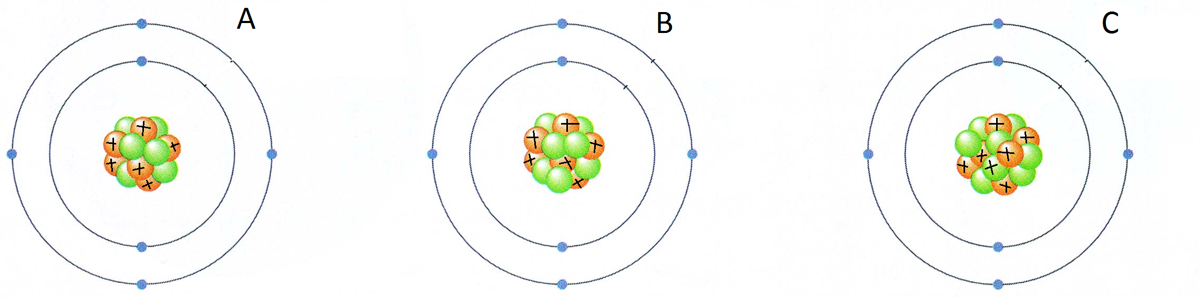

8. Determine the following for the element. (5 marks)

Number of protons: _________
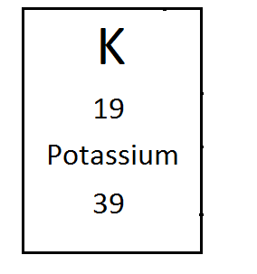
Number of electrons: _________

Number of neutrons: _________

Atomic number: _________

Mass number: _________

Only work on this page after you have attempted EVERY question in the test!
